**IFN636: Software Life Cycle Management: *Template***

**Assessment 1**

Total Marks 20

**Assessment name:** Software requirements analysis and design (Full-Stack CRUD Application Development with DevOps Practices)

**We have provided this template for you. Include all parts of this assessment in one file (this file), convert it to PDF, and then submit it via Canvas before the deadline.**

**The first page (this page: cover page) of your assessment file should include the following information:**

**Mark Distribution:**

**Marks**

* Project design with SysML 3
* Project Management with JIRA 4
* Backend Development (Node.js + Express + MongoDB) 3
* Frontend Development (React.js) 2
* GitHub Version Control & Branching Strategy 2
* CI/CD Pipeline Setup 5
* README.md and Report 1

Total Marks: 20

**Full name: _________________Hyojeong Chin____________________**

**Student ID: ____________________N12118303_____________________**

**Tutor’s name (tutor’s full name): ________ Sk Tanzir Mehedi_________**

**Tutorial day and time: ____________Mon PM 4:00-6:00_______________**

EC2 Instance Name and ID: _________jeongA1, i-0b51584beac9f538b_________

EC2 Instance Link: _________[*https://13.211.153.23/*](https://13.211.153.23/)______________

# Project Overview

I implemented a digital event pass generator by extending the starter application provided in the lecture. This system allows event organisers to register events and issue QR code-based passes to attendees.

Attendees can view, reissue, or cancel their passes, while staff can scan passes to manage attendance records. The backend is built with Node.js, Express, and MongoDB, while the frontend is implemented with React.js. Version control is managed through GitHub, and automated testing and deployment are integrated through GitHub Actions and AWS EC2.

# Project Design

## 2.1 Requirement Diagram using SysML

Include your SysML requirement diagram here and its relationships with a brief explanation

## 2.2 Block Definition Diagram using SysML

Include your SysML BDD diagram here and its relationships with a brief explanation

## 2.3 Parametric Diagram using SysML

Include your SysML parametric diagram here and its relationships with a brief explanation

# Project Management (JIRA)

## 3.1 Provide a public link of the Jira Board or project link

<https://chj9127.atlassian.net/jira/software/projects/DEPG/boards/34?atlOrigin=eyJpIjoiZjY4YWU4MWM3ODg5NDM2N2E2ZTNkMzY2YmNlODBmZjkiLCJwIjoiaiJ9>

## 3.2 Product Backlog Screenshot

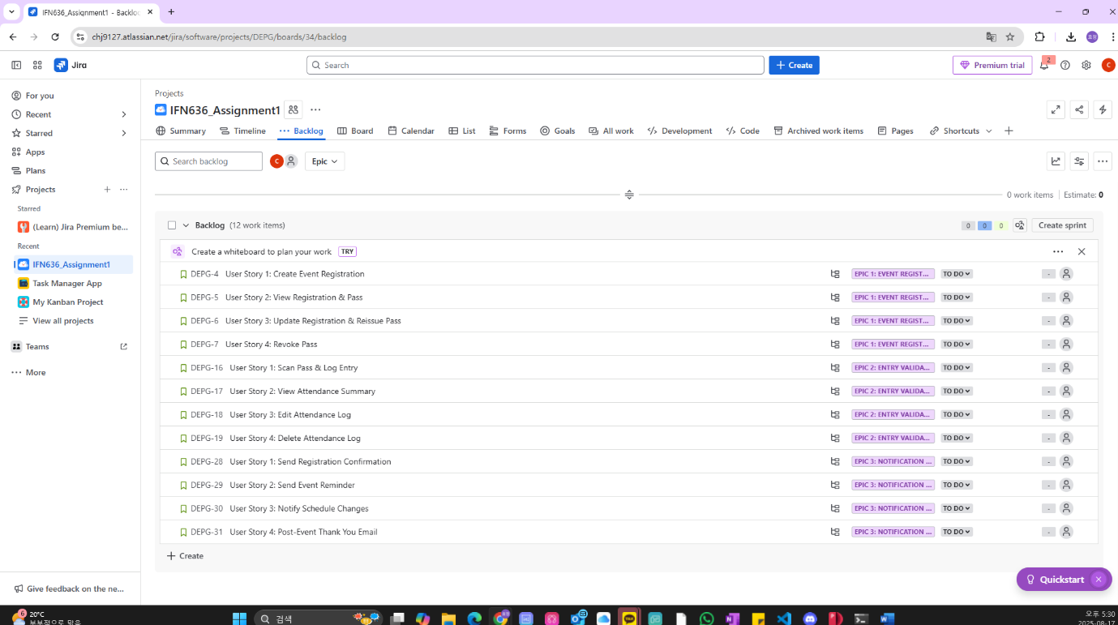

## 3.3 Project Timeline Screenshot (Include Epic, User Story)

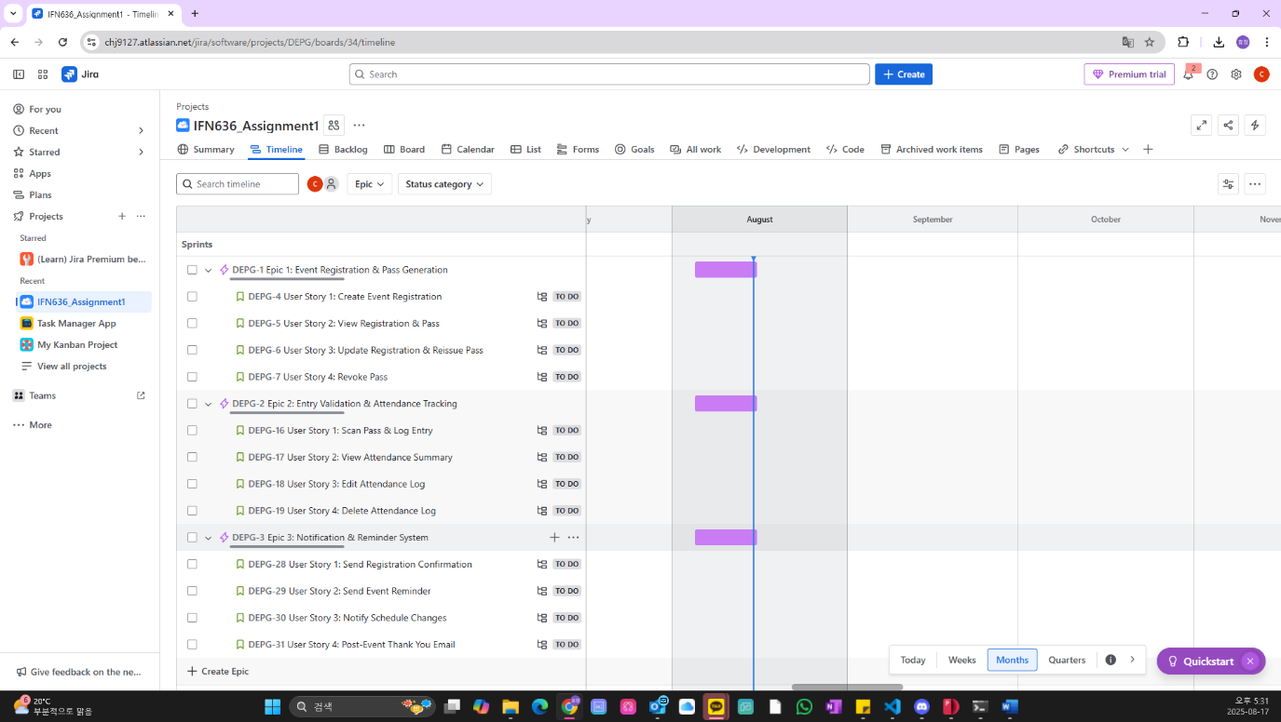

## 3.4 Provide one Screenshot of any one User Story, including subtasks 텍스트, 소프트웨어, 컴퓨터 아이콘, 웹 페이지이(가) 표시된 사진 AI 생성 콘텐츠는 정확하지 않을 수 있습니다.

## 3.5 Provide a Screenshot of where you planned all sprints

텍스트, 소프트웨어, 번호, 컴퓨터 아이콘이(가) 표시된 사진

AI 생성 콘텐츠는 정확하지 않을 수 있습니다.

## 3.6 Provide a Screenshot of where you started one sprint

텍스트, 스크린샷, 소프트웨어, 컴퓨터 아이콘이(가) 표시된 사진

AI 생성 콘텐츠는 정확하지 않을 수 있습니다.

## 3.7 Provide a Screenshot of Jira Board

텍스트, 소프트웨어, 컴퓨터 아이콘, 웹 페이지이(가) 표시된 사진

AI 생성 콘텐츠는 정확하지 않을 수 있습니다.

## 3.8 Provide a Screenshot of the completed sprint

텍스트, 소프트웨어, 컴퓨터 아이콘, 멀티미디어 소프트웨어이(가) 표시된 사진

AI 생성 콘텐츠는 정확하지 않을 수 있습니다.

## 3.9 Provide a Screenshot of the commit history from JIRA

텍스트, 소프트웨어, 컴퓨터 아이콘, 멀티미디어 소프트웨어이(가) 표시된 사진

AI 생성 콘텐츠는 정확하지 않을 수 있습니다.

# Backend Development, Frontend Development, GitHub Version Control & Branching Strategy

*Just provide your GitHub Link and public URL (****your instance’s public IP address)****. We will review your code implementation to verify whether the backend is functioning correctly through the public URL. Additionally, we will also review your commits, main branch, feature branches, and pull requests.*

[*https://github.com/HyojeongChin/IFN636_Assignment1*](https://github.com/HyojeongChin/IFN636_Assignment1)

[*https://13.211.153.23/*](https://13.211.153.23/)

# CI/CD Pipeline Setup

## 5.1 Provide YML file screenshot

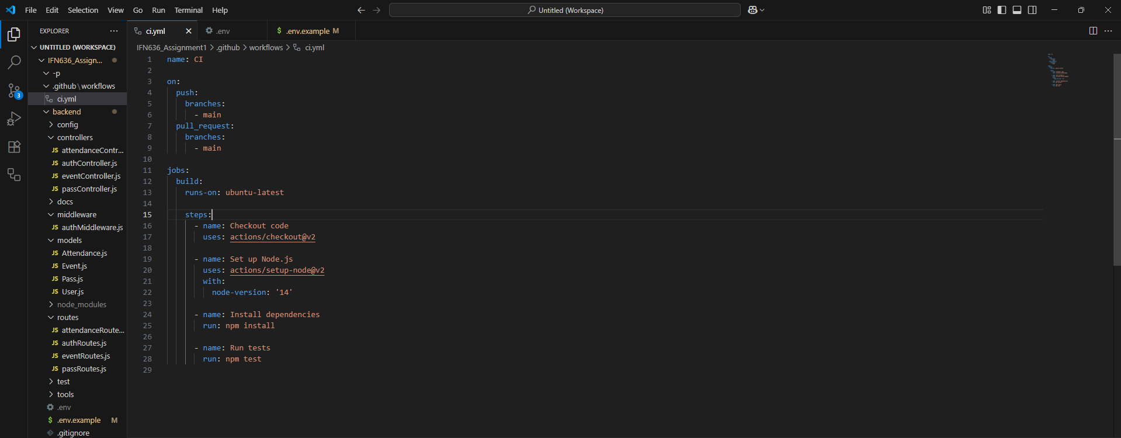

## 5.2 Provide a Test Case pass/fail status screenshot (from the terminal output)

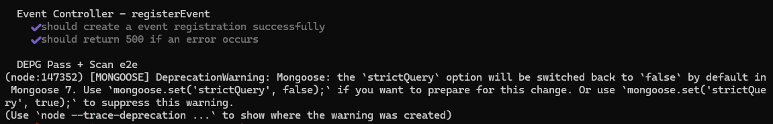

## 5.3 Provide a GitHub Action Configuration screenshot (Include runner, environments, and prod variables setup)

텍스트, 스크린샷, 소프트웨어, 멀티미디어 소프트웨어이(가) 표시된 사진

AI 생성 콘텐츠는 정확하지 않을 수 있습니다.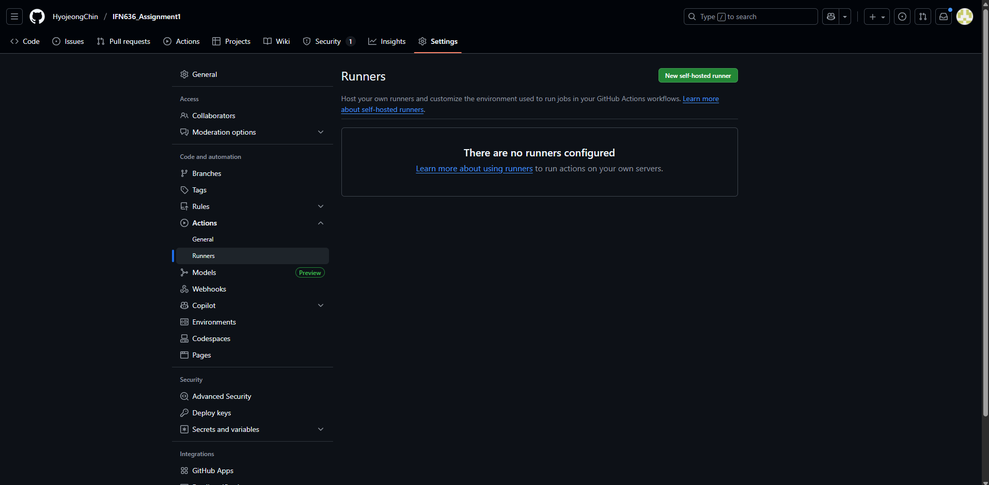텍스트, 소프트웨어, 멀티미디어 소프트웨어, 그래픽 소프트웨어이(가) 표시된 사진

AI 생성 콘텐츠는 정확하지 않을 수 있습니다.

텍스트, 스크린샷, 소프트웨어, 멀티미디어 소프트웨어이(가) 표시된 사진

AI 생성 콘텐츠는 정확하지 않을 수 있습니다.

## 5.4 Provide a screenshot of EC2 server configuration (Only include pm2 status output)

## 5.5 Provide a screenshot of the running project, including public IP (Only one screenshot)

## 5.6 Provide a screenshot of the Final Workflow Run Test through GitHub Action (where the job is running when you push, and you can see all of them are passing or something fails)

# README.md (you can include GitHub readme.md file link or screenshot)

# Discussion and Conclusion

*Through this project, we implemented event pass issuance, scanning, and attendance management functions. I also configured a CI/CD environment using GitHub Actions and AWS EC2 and practised the deployment process. I plan to continue developing and studying further to lay the groundwork for future expansions, including the parts where errors occurred and those that remained unfinished.*

# Reflection

*Although I was quite inexperienced and couldn't complete everything within the given timeframe, and new errors kept occurring, this process allowed me to recognise the importance of requirement analysis, testing, and deployment in software development.*

# References:

Please use APA referencing style, more details about referencing can be found here: <https://qutvirtual4.qut.edu.au/group/student/study/writing-and-referencing/citing-and-referencing>